Nepal College of Information Technology
Assessment
Fall 2010
Program: ELX/CE Time: 3 hrs
Semester: Fall (V) FM: 100
Subject: Integrated Digital Electronics PM: 50

The figures in the margin indicate full marks.
Attempt all the questions:
1 a) Define fan-out and noise margin. Assuming β = 70, V_{BE (on)} = 0.65V, V_{BE (sat)} = 0.75V, V_{CE (sat)} = 0.2V, calculate fan-out for the BJT inverter G1 shown below when NM_{H} =0. [7]
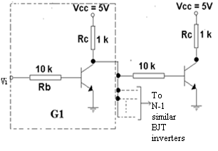
b) Explain why the rise time in RTL buffer when driving a capacitive load, is significantly less in comparison to that in ordinary RTL gate. Derive the expression for the output current(I_{o}) when the transistor employed for the active pull-up is in saturation. [8]

2. a) At T=125°C, assuming the temperature sensitivity of the emitter junction as well as the diode is -2 mV/°C., answer the following questions, referring the following circuit. [10]
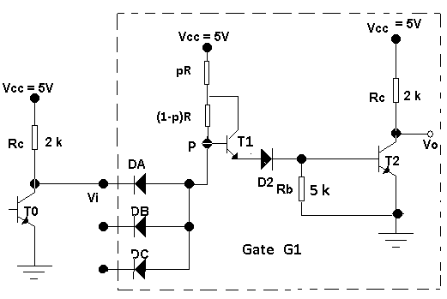
i) Calculate the input voltage V_{i} when the transistor T₂ is at the edge of cut-off.
ii) Calculate the change in current ∆I_{D2} flowing through the diode D2 when the transistor T2 switches from the edge of cut-off to the edge of saturation. Assume h_{FE} =50 and σ=0.85.
iii) Calculate the input voltage V_{i} when the output transistor T₂ is at the edge of saturation and when the diode DA just cuts off.
iv) On the basis of above calculations, plot the input-output characteristics of the above shown DTL gate G1 at 125 °C.
b) The OR output of the ECL gate is shown below to be fanned out to N similar gates. Find N at room temperature if the ∆1 noise margin is to be zero. Assume that the resistors of driving stage are 10% higher than typical and the resistors of driven stages are 10% lower than typical. The supply voltage is 5% higher and the transistor have current gains, h_{FE} = 40.The departures from the typical values are all in the direction to reduce the fan-out. The typical values are R_{C2} =300Ω, R₄ =1500Ω, R_{e} =1180Ω and V_{EE}=5.2V. [5]
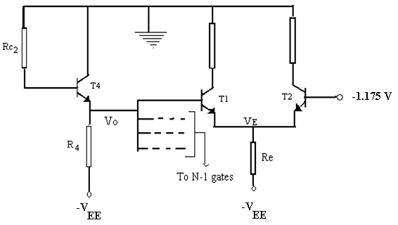

3. a) Draw the high speed TTL circuit and explain how the following factors account for the high speed in it. [8]
i) The input diodes
ii) The darlington circuit
iii) The active pull-down
b) Draw the ECL gate and explain OR operation in it. [7]

4. a) Compare the various bipolar logic families on the basis of the following design parameters, fan-out, power dissipation, noise immunity and switching speed. [7]
b) Consider the CMOS inverter given below. For K_{n} = K_{p} , V_{T} (n) = V_{T} (p) = 2V and V_{SS} =10V, find the unique input voltage V_{i}(sat) defined by the simultaneous saturation of both transistors. [5]
c) The rise time in NMOS is extremely long in comparison to the fall time whereas in case of CMOS both are almost equal. Why? [3]

5. a) Explain read, write and refresh operations in a four-transistor MOS dynamic cell. [7]
b) Explain the basic operating principle of analog gates. A three-channel multiplexer with its associated gating drive and a ring counter is shown below. Discuss the operation of the circuit in detail. [3+5]
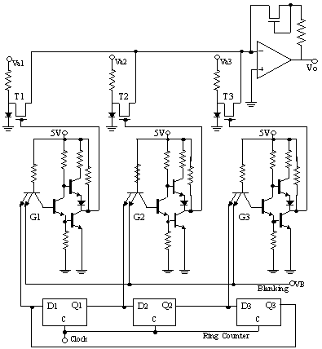

6. a) Give an introduction of VHDL and explain the certain terms related to it. [7]
b) Consider a simple digital circuit that warns car passengers when the door is open or the seatbelt is not used, whenever the car key is inserted in the ignition lock. Give the behavioural as well as the structural description of the circuit using VHDL. [8]

7. Write short notes on.(Any Two) [10]
a) ECL gate interconnections
b) Charge Coupled Device
c) Analytic equations of MOSFETs
d) An integrate-and-dump circuit.

